Health system leadership is concerned with high rates of ED utilization and the limited reimbursement they receive for this costly service. They are considering launching an initiative to target individuals likely to visit the ED in the next three months for enhanced care coordination and outpatient services. They have asked you to prepare a report that includes:

- Trends in ED visits by month.
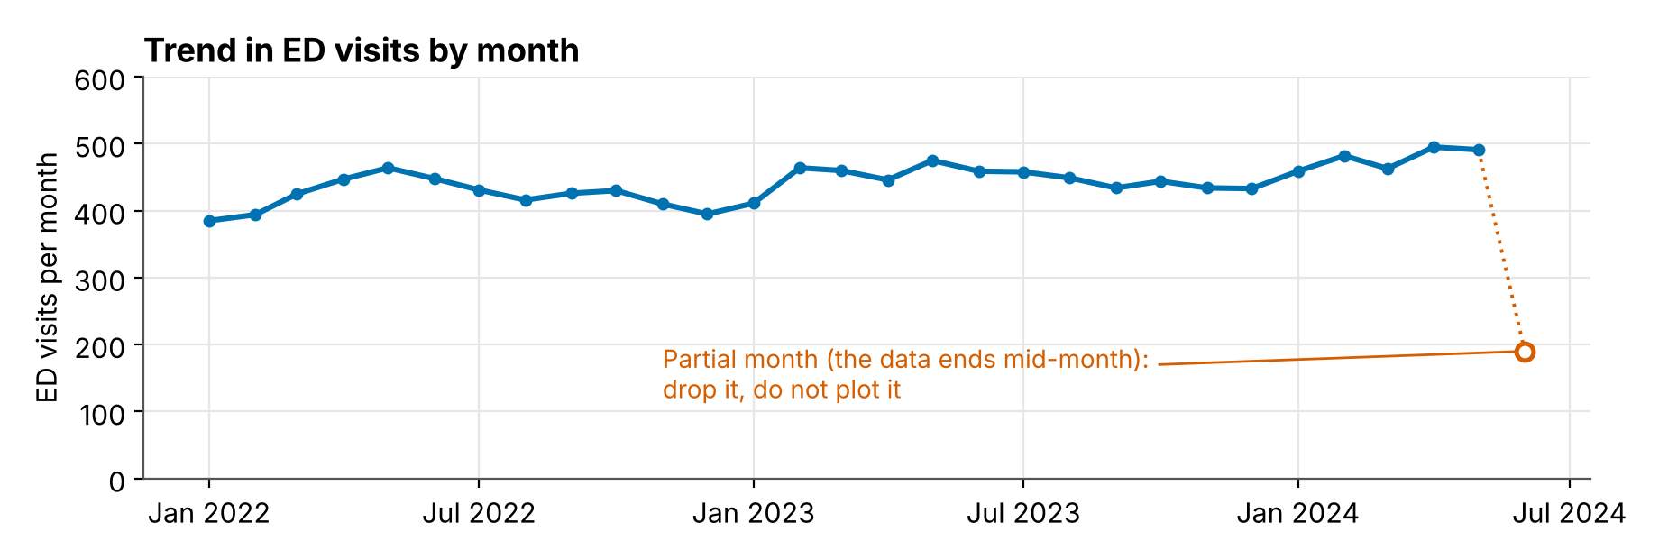
- ED visits by payer because they are substantially concerned about high rates of visits from payers that do not reimburse well.
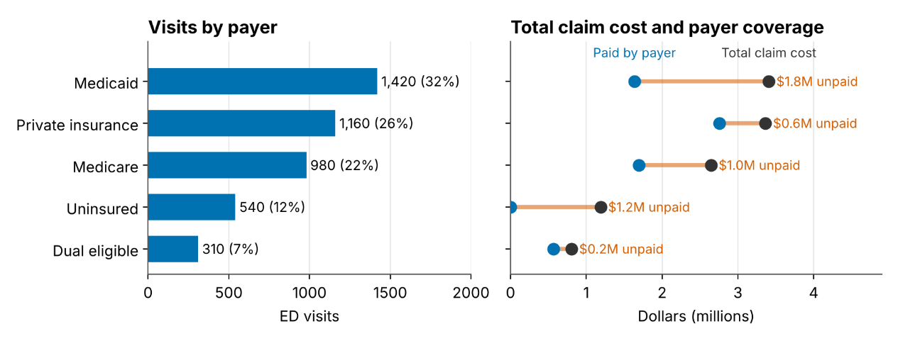
- A Lorenz Curve to identify the degree of concentration in ED costs.
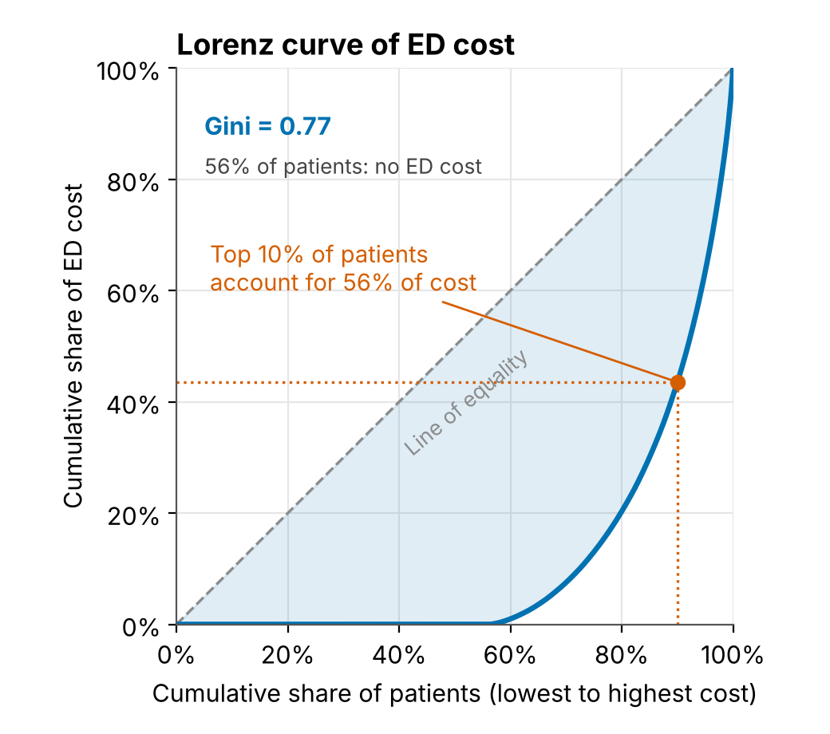
For security reasons, your health system doesn’t like downloading new R packages, so each of these is to be built using standard ggplot.

For each plot consider:
- What Synthea database tables do you need to pull from and what columns?
Deliverable | Tables | Columns
Trends | encounters | id, patient, start, encounterclass
Visits by payer | encounters, payers | encounters.id, patient, start, payer, encounterclass, total_claim_cost, payer_coverage; payers.id, name
Lorenz | patients, encounters | patients.id; encounters.patient, encounterclass, total_claim_cost

- What shape does the data need to be in to plot it? How will you wrangle it into that shape?
Deliverable | One row per | Columns after wrangling | Key step
Trends | Month | month, ed_visits | Include months with zero visits; drop partial months; count each patient-date once
Visits by payer | Payer | payer, ed_visits, share_of_visits, total_claim_cost, payer_coverage | Label a missing payer; sum dollars by payer (sums, not averages); sort payers by visits
Lorenz | Patient | cum_patients, cum_cost (from patient_id, ed_cost) | Sort ascending, then cumulative sums and shares; add the (0, 0) point

- What do we need to inspect about the data to ensure our figures are correct?
Deliverable | What to inspect | What you are looking for
Trends | Distinct values of encounterclass  Visits per month  First and last month complete  Visits per patient per day (the same patient-date more than once) | Wrong class included, a partial first or last month, spikes from duplicates
Visits by payer | Distinct payer names  Missing payer  Visits by payer add up to total visits  payer_coverage versus total_claim_cost | Spelling variants, a null payer, double counting, coverage greater than cost
Lorenz | Share of patients with zero cost  Distribution of cost  Negative or missing costs  Which patients are in the population | Zero-cost patients dropped by mistake, a few huge costs driving the curve, costs in cents instead of dollars

- What do we need to test about our code to ensure it is producing the expected outcome?
Deliverable | Test ideas
Extract | A clean fixture comes back unchanged  A fixture with each problem raises an error that names it: an urgentcare row, a duplicate ID, a negative cost, a missing cost, a cost in cents, coverage above cost, "Medicaid " with a trailing space, a date outside the window
Trends | The same patient-date twice counts once  A month with no visits appears with a count of 0  A partial last month (and first month) is dropped  ed_visits sums to the hand count on the fixture
Visits by payer | Shares sum to 1  Visits by payer sum to total unique visits  A missing payer ends up in the "Unknown" category  An uninsured payer with zero coverage keeps its row  Dollar totals match the hand count on the fixture
Lorenz | Starts at (0, 0) and ends at (1, 1)  Never rises above the diagonal  A zero-cost patient adds a row (n patients give n + 1 rows)  A negative or missing cost raises an error  The hand-worked example gives a Gini of 0.48  Equal costs give a Gini of 0
Plots | Each plot function returns a ggplot  It is built from a table with the expected columns

Structure
Everything we want to test has to be reachable from a test file. That means the work lives in small functions that take data and return data, and the plotting scripts only call them. Functions take data frames or vectors and return data frames, numbers, or ggplot objects. No database calls, file paths, or printing inside them.
- R
  - extract.R – MariaDB R SQL wrapper to generate initial data frames
  - prep.R – validate data and create plotting data
  - plots.R – plot figures
- testthat.R
  - testthat/test-prep.R
  - testthat/helper-fixtures.R – CLAUDE: Can these fixtures be generalized to allow for testing of prep.R and plots.R before SQL is generated.
- report.qmd – compile final report. Run tests, validations from here

Functions
Function (suggested name) | Input, Purpose and output | Data evaluations | Tested for
validate_ed_visits(visits) | Input: Visits table  Output: Visit table, returned unchanged OR an error | EXAMPLE: Only emergency encounters (no urgentcare)  Encounter IDs are unique  No negative or missing costs  No cost above a plausible maximum (dollars, not cents)  payer_coverage not greater than total_claim_cost  Payer names in the allowed set (a missing payer is allowed)  Visit dates inside the study window | A clean fixture comes back unchanged  A fixture with each problem raises an error that names it: an urgentcare row, EXAMPLE: a duplicate ID, a negative cost, a missing cost, a cost in cents, coverage above cost, "Medicaid " with a trailing space, a date outside the window
monthly_counts(visits, data_end) | Input: Visits table; last date in the data (data_end)  Output: One row per complete month (month, ed_visits) | Each patient-date counted once  EXAMPLE: Months with no visits filled in with 0  Partial first or last month dropped  ed_visits sums to the distinct patient-date visits in the complete months | EXAMPLE: The same patient-date twice counts once  A month with no visits appears with a count of 0  A partial last month (and first month) is dropped  ed_visits sums to the hand count on the fixture
payer_summary(visits) | Input: Visits table  Output: One row per payer (payer, ed_visits, share_of_visits, total_claim_cost, payer_coverage) | EXAMPLE: Missing payer labeled "Unknown" and kept  One row per payer, including payers with zero coverage  Visits by payer add up to total visits  Dollars summed by payer, not averaged | EXAMPLE: Shares sum to 1  Visits by payer sum to total unique visits  A missing payer ends up in the "Unknown" category  An uninsured payer with zero coverage keeps its row  Dollar totals match the hand count on the fixture
lorenz_curve(costs) | Input: Vector of patient costs  Output: A curve table (cum_patients, cum_cost) | EXAMPLE: Zero-cost patients kept  Stops on a negative or missing cost  Sorts ascending, then cumulative sums and shares  Adds the (0, 0) point | EXAMPLE: Starts at (0, 0) and ends at (1, 1)  Never rises above the diagonal  A zero-cost patient adds a row (n patients give n + 1 rows)  A negative or missing cost raises an error
gini(costs) | Input: Vector of patient costs  Output: One number between 0 and 1 | Built on lorenz_curve(), so the same checks apply | The hand-worked example gives a Gini of 0.48  Equal costs give a Gini of 0
plot_trend(), plot_payer(), plot_lorenz() | The tables above to a ggplot object |  | Each plot function returns a ggplot  It is built from a table with the expected columns

Two inspections have no function because they are judgment calls: whether a few huge costs are driving the Lorenz curve, and which patients belong in the population. Report both in the brief.

